The samples contain the following chemicals.

**Barium Chloride**

**Sodium Carbonate**

**Zinc Nitrate**

**Calcium Carbonate**

**Barium Sulfate**

**Sodium Chloride**

Please replace the vial lids as soon as you have finished using the sample.

**Please note the chemicals have the following warnings**

* **Laboratory Reagent**

**Do not breathe dust**

**Avoid contact with skin and eyes**

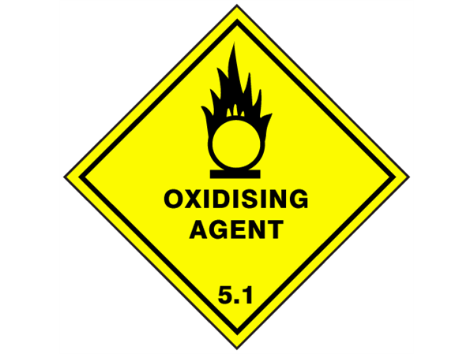

* **Warning**

**Harmful is swallowed**

**Irritating to skin and eyes**

**Contact with combustible material may cause fire**

**In case of contact with eyes, rinse immediately with plenty of water & seek medical advice**

* **Caution S5**

**Irritating to eyes**

**Do not breathe dust**

**Avoid contact with eyes**

**In case of contact with eyes, rinse immediately with plenty of water & seek medical advice**

* 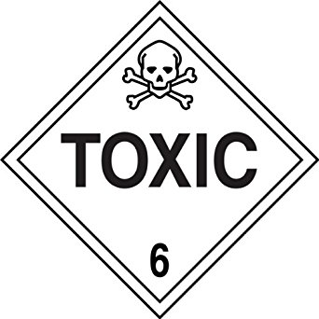**Poison S6**

**Harmful by inhalation**

**Toxic if swallowed**

**Avoid contact with skin and eyes**

**Do not breathe dust**

**In case of accident or if you feel unwell, seek medical advice immediately**

* **Laboratory Reagent**

**Not to be taken**

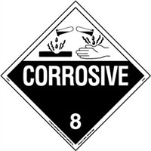**Sulfuric Acid H2SO4 2.0M**

**Poison S6**

**Causes burns**

**In case of contact with eyes rinse well with water and seek medical attention**